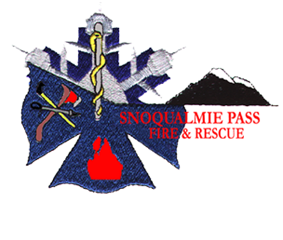
Snoqualmie Pass Fire & Rescue

PETITION FOR ADJUSTMENT OF BENEFIT CHARGE ASSESSMENT

DUE DATE: All items must be completed and petitions Petition No._____
received by February 10th , 2025 by 5:00 p.m. (Do not fill in)

Review Board Hearing: February 19st , 2025 at 6:00 p.m.
(all appeals will be considered, it is not required that you attend the hearing).

In accordance with the provisions of Chapter 52.18.070 Revised Code of Washington, I, __________________________, do hereby respectfully petition Snoqualmie Pass Fire & Rescue Benefit Charge Review Board to change the Benefit Charge Assessment of the following described property for the year 2025 to that amount shown in Item No. 6 of the form.

1. Parcel Number and Address of Property:

2. General description of property:
A. Building use:
B. Brief description of building (include type of construction, height):

C. Square footage of buildings and improvements, including garages, excluding decks and uncovered porches:

3. Snoqualmie Pass Fire & Rescue Benefit Charge Assessment for the year 2025
$

4. Specific reasons why the Benefit Charge Assessment is being challenged:

5. Attached are maps, pictures, letters or other data to substantiate the challenge.
Exhibit number: _____ Brief description of exhibit:

6. On the basis of the foregoing reasons, I request that the Benefit Charge Assessment for this property for the Year 2025, should be changed to $______________

I hereby certify that to the best of my knowledge and belief the information entered on this petition is a true and fair presentation of the facts relating to this appeal.

Signed this ______ day of ______________, ______
(year)

Signature:

___________________________ Business Phone:
Owner

___________________________ Home Phone:
Agent

Mailing Address for Correspondence

Please mail to: Snoqualmie Pass Fire & Rescue
PO Box 99
Snoqualmie Pass, WA 98068

Or email to: jwiseman@spfire.org

